TSTA Agenda
Oct 14, 2022 11am CST Zoom Meeting 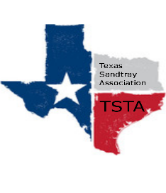
Executive Team & Officers in Attendance
_x_ Salina Loriaux, President _x_ Michelle Beyer, Secretary
_x_ Sheri Shulenberger, President-Elect _x_ Melissa Fleming, Public Relations
__ Amanda Robinson, Executive Assistant _x_ Karen Burke, Founding Advisor

- Financial update - $3458.57
- Website update - 183 visitors, down 36%; 4 new visitors, down 50%
- Review website changes -
- Election - send out position nominations - president elect, secretary, public relations
- Conference Debrief
- Karen requesting use of miniatures - approved
- Anything else……………………..
- General updates and next meeting Nov 18th

