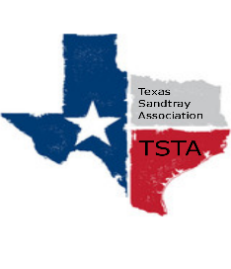
July 13, 2020 10:00 am Zoom Meeting
s

TSTA Agenda

Executive Team & Officers in Attendance
_x_ Karen Burke, President _x_ Sheri Shulenberger, Secretary
_x_ Raquel Sadler, President-Elect _x_ Missy Whitsett, Public Relations
_x_ Amanda Robinson, Executive Director

- Financial update: Balance $4,279.55
Members are beginning to renew membership.
- Training meeting on 17th: Karen to offer trainer meeting.
Keeping the website fresh with upcoming trainings; in addition, have the ability to review past events.
- APT training requirements during pandemic: Regarding Zoom trainings for APT: 40 participants or less/receive contact hours; 40 or more participants/receive non-contact hours. (Must be advertised as to the type of hours to be received.) Training time must be 2 or more hours. Must give participants a quiz in addition to evaluation and video must be on. Board agrees it is beneficial for TSTA to have the ability to provide APT hours.
- Ideas for future training: EMDR and sandtray; Ethics
Moving forward: New requirement effective January 1, 2021. When participants complete levels 1-4 then they will have 1 year to complete the train the trainer course. Previous participants of levels 1-4 will be grandfathered. Amanda to update the website and an email will be sent out to the membership; also social media announcements.
There was discussion about offering levels 3 and 4 online but no decision at this time.
There was discussion about paying a trainer to present online training for continuing education. Raquel to consider what we need to set up parameters.

- Professional Goals of Officers: Karen to send email document to board members so each person can set goals for self during term.
- Any other updates/topics: Karen gave description of Advisory Board-former officer that is available to offer guidance/give objective outside view at board request.
Other items: Lacy is currently the APT reviewer. Amanda to take on role of APT reviewer if it is a matter of completing a form only; Renewal for APT provider expires on July 31, 2021.
Raquel ready to start putting the message out about the 2021 conference and be looking for a flexible presenter (in-person vs. virtual) due to unknown COVID conditions. TSTA ready to offer online CEs now; looking for trainers/ideas for presentations to keep members engaged.

