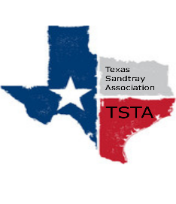
October 1, 2021 10:00 am Zoom Meeting
s

TSTA Minutes

Executive Team & Officers in Attendance
x Raquel Sadler, President x Sheri Shulenberger, Secretary
x Salina Loriaux, President-Elect x Melissa Fleming, Public Relations
x Karen Burke, Past-President x Amanda Robinson, Executive Director
x Michelle Beyer, Conference Committee Coordinator
- Financial update: $5, 034.07
- Website update: 169 hits down 49%; 2 new down 33%
- Conference Recap
  - Conference profit & loss: Income: $2,550.00; Expenses: $3,882.28; Total loss: ($1,332.28)
  - Evaluation feedback from attendees: Overwhelmingly positive
- TSTA address: Address needs to change since it was at Karen’s business; discussed an option of a registered agent to handle the mail and forward to Amanda.
- General updates and next meeting TBD for November: Approved provider for APT CE evaluation not in compliance; Amanda to correct and resubmit. Next TSTA meeting set for Friday, November 12, 2021 @ 10:30am via Zoom.

