Presentation Proposal
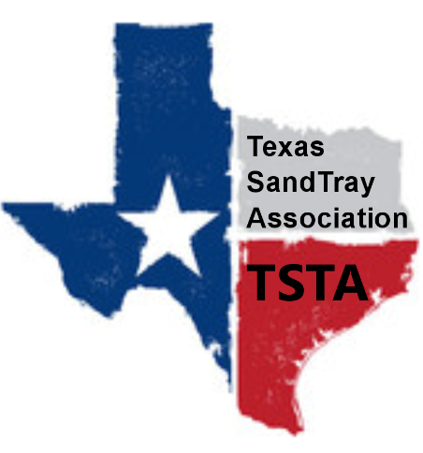
Texas SandTray Association CEU Trainings

Please submit your presentation proposal by email to txsandtray@gmail.com

Until further notice, all TSTA trainings will be held via ZOOM. TSTA holds a professional account which trainers will be able to use during such trainings. We are a provider for the Association for Play Therapy and thus may ask that
wording be tweaked to meet the guidelines required for CEU credit.

Name of Presenter:

Credentials:

If you are an intern, associate, or practicum student, please include your supervisor’s contact, email, and phone number:

Short Biography (or attach resume or vitae) and please include your experience with sandtray:

Name of Presentation (please include the words “play therapy” in the title):

Number of hours the presentation will last (minimum of 2 hours please): ___________

Description of Presentation:

Target Audience:

Learning Objectives (please include the words, “play therapy”, throughout:

APT requires that you use 3 current sources (published within the last 5 years). Please list those sources:

What, if any, materials do you need participants to have available for the training?

