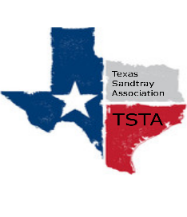
July 30, 2021 10:00 am Zoom Meeting
s

TSTA Minutes

Executive Team & Officers in Attendance
__ Raquel Sadler, President x Sheri Shulenberger, Secretary
x Salina Loriaux, President-Elect x Melissa Fleming, Public Relations
__ Karen Burke, Past-President __ Amanda Robinson, Executive Director
x Michelle Beyer, Conference Committee Coordinator
- Conference
  - Kits to mail: Discussed bubble wrap envelopes (with TSTA logo sticker) to send out kits containing:
      - Mandala coloring sheets with markers or colored pencils
      - Stress ball with TSTA logo
      - Meddy Teddy yoga keychain (miniature)
      - Gift card for lunch ($20/$25 depending on budget)
      - Include note card with logo setting intention of conference
Michelle will research prices and items needing a logo.

- Next meeting Friday, August 20 and Friday, September 10, 2021
Conference date set for Friday, September 17, 2021. Title of conference: Redefining Self-Care Through Sandtray Play Therapy.

