TSTA Minutes
July 1, 2022 10am CST Zoom Meeting 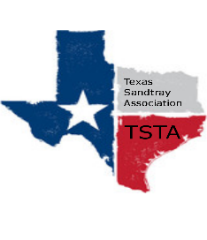
Executive Team & Officers in Attendance
__ Salina Loriaux, President _x_ Michelle Beyer, Secretary
_x_ Sheri Shulenberger, President-Elect _x_ Melissa Fleming, Public Relations
_x_ Amanda Robinson, Executive Assistant __ Karen Burke, Founding Advisor

- Conference -
  - Ruby Ranch, in person, come at your own risk; only on Friday September 16th, $1200, pay ⅓ or ½ right now; Melissa filling out contract
  - Double checking with presenters for proposals - Wanda’s is official, Kim deadline next Friday - Melissa coordinating this and social media
  - Amanda sending out save the date email blast; Amanda updating CE’s
  - Amanda will do website and registration
  - Michelle will head up breakfast/lunch options
  - Printing stuff - Sheri volunteer - folder, creating schedule etc
  - Picking up minis and sandtray - all Austin people; Karen head that up?
  - 9-4 with hour off for lunch; Board there by 8 am
  - Cost of conference - $150 members; $185 non-members
  - Miniature and pen to take home - Salina?
  - Welcome letter from president - Salina?
  - Anticipating 60 ish people, max 100 people
- Next meeting July 22nd and August 5th

