TSTA Agenda
June 17th, 2022 10am CST Zoom Meeting 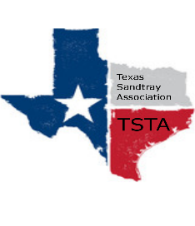
Executive Team & Officers in Attendance
_x_ Salina Loriaux, President _x_ Michelle Beyer, Secretary
_x_ Sheri Shulenberger, President-Elect _x_ Melissa Fleming, Public Relations
_x_ Amanda Robinson, Executive Assistant _x_ Karen Burke, Founding Advisor

- Financial update - $2010.78
- Website update - 224 visits, up 1%, 3 new people up 200%; most time spent at trainer page, then conference page
- Conference Budget - last year spent $3800
- Conference Venue - Contacting different venues and making plan by Friday 6/24
- Conference Brainstorming - Presenters need to fill out presenter form; 6 CEs; Tentative date Sept 16th
- Conference Price - virtual - $150 non members, $125 members; in person - $175 tentative
- Potential Summer Training -
- Uvalde search for volunteer providers - connecting therapists to volunteer in Uvalde
- Anything else……………………..
- General updates - Next meeting July 1st at 10am

