TSTA Agenda
May 20th, 2022 10am CST Zoom Meeting 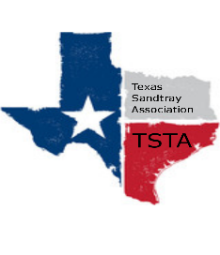
Executive Team & Officers in Attendance
_x_ Salina Loriaux, President _x_ Michelle Beyer, Secretary
_x_ Sheri Shulenberger, President-Elect __ Melissa Fleming, Public Relations
_x_ Amanda Robinson, Executive Assistant _x_ Karen Burke, Founding Advisor

- Financial update - $2462.78
- Website update - 217 hits, up 40%, one new hit
- Conference Budget
- Conference Brainstorming - location - Salina reaching out to Vintage Villas, Melissa reaching out about conference chair
- Anything else……………………..
- General updates - potential summer training, and next meeting for June 17th at 10am

