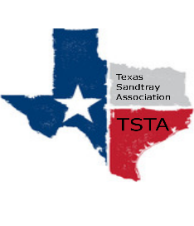
January 13, 2023 10:00 am CST Zoom Meeting
s

TSTA Minutes

Executive Team & Officers in Attendance
x Sheri Shulenberger, President x Nancy Franklin, Secretary
x Tamara Fields, President-Elect x Taylor Vest, Public Relations
x Salina Loriaux, Past-President x Amanda Robinson, Executive Assistant
x Karen Burke, Founding Advisor

- Monthly Update:
- Financial: $2,391.87
- Website: 239 visitors/past 30 days; up 15%; 2 unique leads
- CCST: 33 Active
- TSTA: 48 Active members
- Mission of TSTA: Karen read mission statement of TSTA; discussed possible mission statement for the TSTA board
- Executive Assistant position open: Amanda to complete work through February 2023; will write job description and submit to board
- 1099 for the Executive Assistant: Amanda to complete 1099
- Effects of scholarships on trainers/training monopolies/guideline ideas: Board discussion of scholarships and creating guidelines
- General updates and next meeting TBD for February: No updates/Next TSTA Board meeting scheduled for Friday, February 10th via Zoom at 10:00am CST.

